**21L-5654**

**LAB 2**

**Q1**

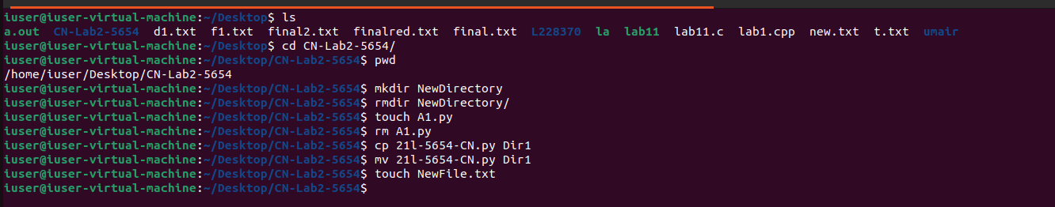

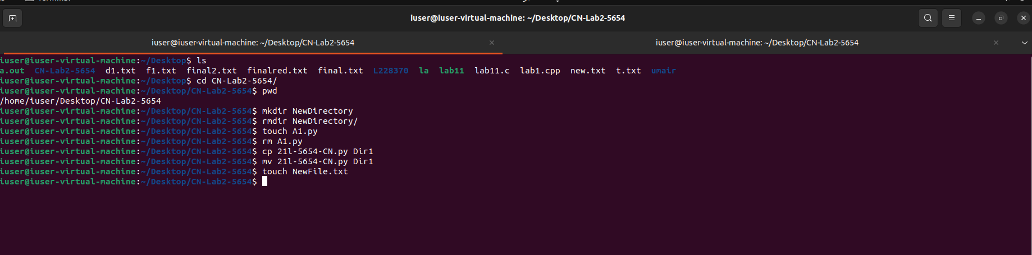

Q2:

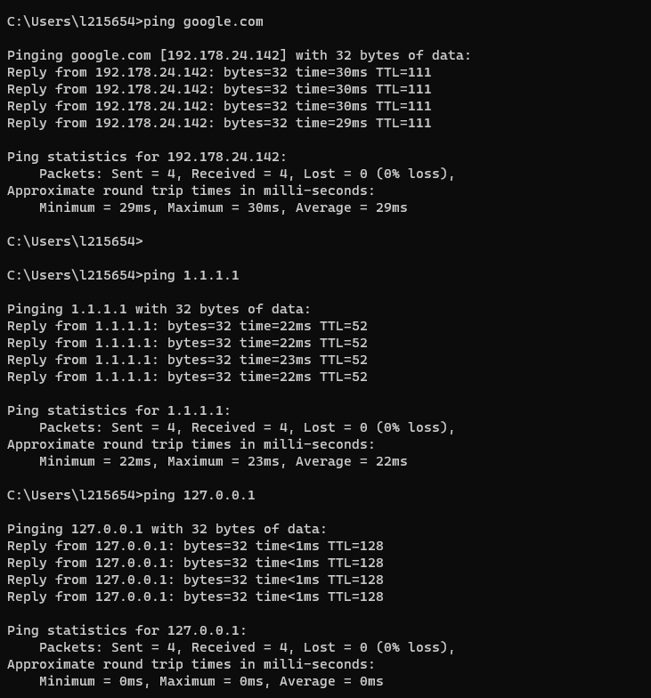

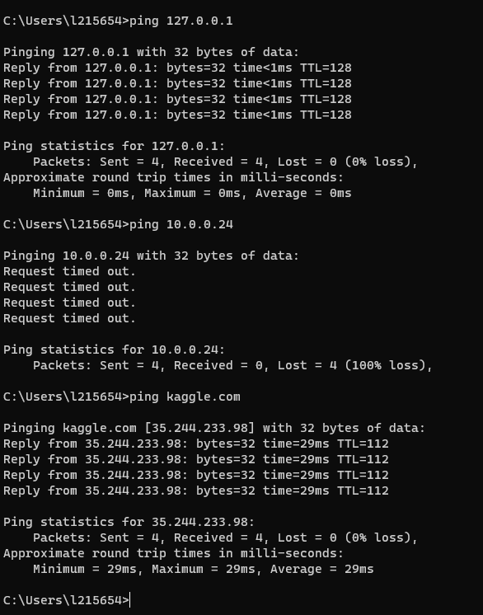

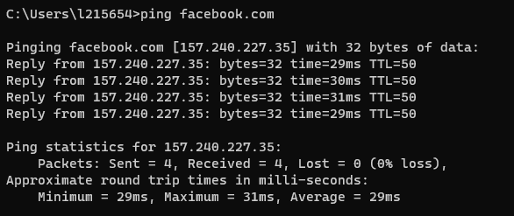

Latency times:

1. Google.com: latency time:3004ms
2. 1.1.1.1:2004ms
3. Kaggle.com:1002ms
4. 127.0.0.1 :3077ms
5. Facebook.com 2900ms

The latency time of Kaggle.com is smallest and 127.0.0.1 is highest.

Q4

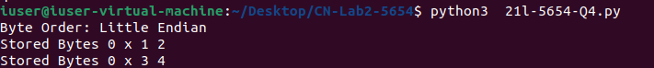

Q5

